**LP14300656542 needs to be virtually loaded to SL001**

**Occurrence of Issue:** The User is not able to load properly into respective SL and ship further. So We need to load it Virtually.

**Incident Documentation:**

**Summary**  :

LP14300656542 needs to be virtually loaded to SL001.  
Category : Software

Location : Branch: Mesa, AZ, wh.143

Software: Korber

Subcategory: Error message

Tried to consolidate LP14300720892 to LP14300656542 to correct the loading issue. Now both LP's need to be virtually loaded to SL001 and shipped. Ref. below.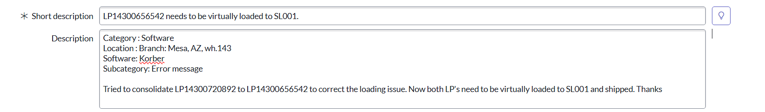  
**Initial Investigation :**  
  
1. We asked User to provide the load id for these LPs which you want to staged into SL001 location from pack location PACMLD.  
  
2. After discussion we moved the item from pack location to staging as discussed.

3. We received following reply from the User on Email :-  
”LP14300656542 is indeed in SL001. However, Korber is not showing Begin Loading under Create Task so we cannot move forward to ship the load. The 14 LPs are indeed in SL001. It appears Korber is buggy. See both snippets below.”  
  
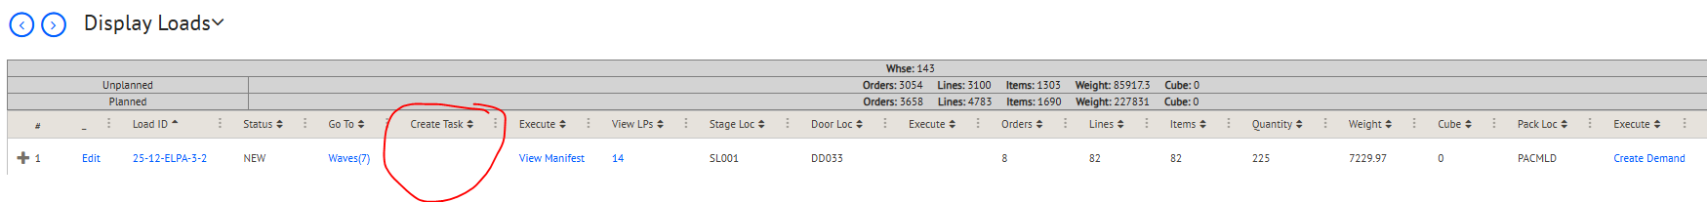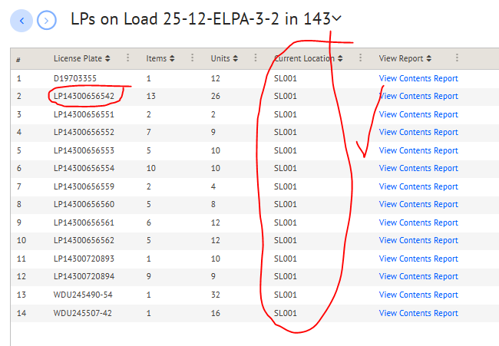  
4. Then we performed some of the below Queries to fix and ship load id from Koerber which was provided by User.  
  
**Queries used for investigation:**   
  
**Step 1**: Ask the User to provide Load ID and other respective details.

**Step 2**: Check hu_id in t_hu_master in AAD database over Korber:-  
select * from t_hu_master (nolock) where hu_id in ('LP14300720892', 'LP14300656542')

**Step 3:** Check hu_id and item_number in t_stored_item in AAD database over Korber:-  
select * from t_stored_item (nolock) where --hu_id in ('LP14300720892', 'LP14300656542') and

item_number in ('12VBATTERYPACK', 'ALBIONBATTERY', 'ZNITRILEL') and wh_id = '143' and type != 0  
  
**Step 4**: Check Status in AAD database over Korber:-  
select status, * from t_order (nolock) where order_number = '578800'  
  
**Step 5**: Pick Id from type t_stored_item in t_pick_detail in AAD database over Korber:-  
select * from t_pick_detail (nolock) where pick_id in (select type from t_stored_item (nolock) where hu_id in ('LP14300720892', 'LP14300656542'))

**Step 6**: Check load_id in t_pick_detail in AAD database over Korber:-  
select * from t_pick_detail (nolock) where load_id = '25-12-ELPA-3-2'  
  
S**tep 7**: Check sources_hu_id in t_tran_log in AAD database over Korber:-  
select * from t_tran_log (nolock) where source_hu_id in ('LP14300720892', 'LP14300656542') order by tran_log_id desc.  
  
**Step 8**: Then check the pick_id in t_pick_detail in AAD database over Korber:-  
select * from t_pick_detail (nolock) where pick_id in (

'11817361',

'11817354',

'11817348')  
//--25-12-ELPA-3-2

**Resolution:**   
**1.** If all the orders are in a SHIPPED or CANCELLED status, update the load to SHIPPED status.  
  
UPDATE t_load_master

SET status = 'COMPLETE'

where load_id in ('LP14300720892', 'LP14300656542')

AND status = 'INPROCESS'  
  
We will we inform client The load ID had been shipped from Koerber  
**Incident Resolution Note**: Once it is done, We will inform client The load ID had been shipped from Koerber.